Searching for Documents

With Google Docs

Google Docs allows the user to perform word or phrase searches on all documents to help the user find a particular document quickly. The following steps will illustrate the process.

- In the field to the left of the Search Docs button, type in a word or phrase to search for in the documents.

Click the Search Docs button.

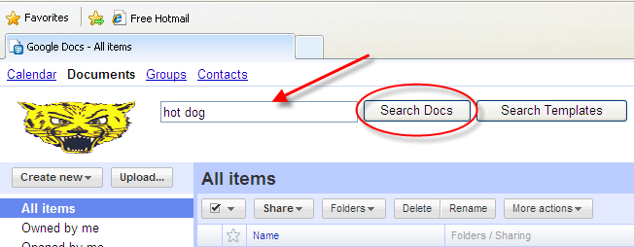

- Depending on the word or phrase, the Search Docs process will return nothing, one document, or multiple documents.

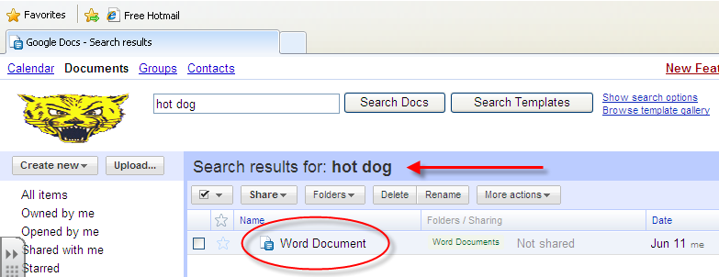

- The documents that are returned will contain the word or phrase within the title or inside of the document.

Double click on the document to open it.

